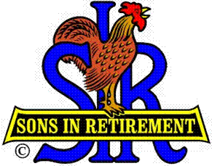

Las Trampas Branch 116

Luncheon Meeting Agenda

April 16, 2018

11:30 AM
- Call to Order – Big Sir.
- Welcome
- Pledge of Allegiance.
- Invocation Lou Sandor
- Story Teller Roger Craig
- Introduce Head Table
- Little Sir: Jerry Hicks
- Guest Speaker – Dick Callahan, Bay Sports Area Legend
- New Member Jerry Zampino with Bernie Wroblewski
- Guest Ed Thomas with Tom Eller
- Introduce Guests & Visitors
- Guests:
- 2017 and 2018 New Members please rise and introduce yourselves.
- Visitors:
- Ed Thomas, Sponsor, Tom Eller
- Andy Myhr and Tom O’Brien and Peter Magnani, Sponsor Jerry Hicks
- Introduce New Members, Jerry Zampino, sponsor Bernie Wroblewski
- Big Sir Comment
- Thank you Jerry Hicks, Little Sir for March Meeting
- New Member Jerry Zampino

No meeting in May SEE YOU ALL IN JUNE “SPRING FLING” in May

11:45 PM – Lunch
- Raffle Drawing
- Sunshine Report
- Committee Reports

12:15 PM Let’s Eat

12:30 PM
Little Sir:
- Introduce Guest Speaker – Dick Callahan
- Ask February Birthday guys to stand / sing Happy Birthday (Paul King & Robbie)
- Sign off by Big Sir
- NO MEETING IN MAY SEE YOU IN JUNE SPRING FLING IN MAY
- Sign God Bless America.

